# Marwiz: TV Application

**Major Project Report**

*Submitted in Partial Fulfillment of the*

*Requirements for the Degree of*

**BACHELOR OF TECHNOLOGY**

**IN**

**COMPUTER SCIENCE & ENGINEERING**

By

## Yash Rawat

## (20BCP270)

## Under the Guidance of

## Prof. Dr. Rutvij Jhaveri



**Department of** **Computer Science & Engineering,**

**School of Technology, Pandit Deendayal Energy University,**

**Gandhinagar 382 426**

**May 2024**

**Certificate of Originality of Work**

I hereby declare that the B.Tech. Project entitled “Marwiz: TV Application” submitted by me for the partial fulfillment of the degree of Bachelor of Technology to the Dept. of Computer Science & Engineering at the School of technology, Pandit Deendayal Energy University, Gandhinagar, is the original record of the project work carried out by me under the supervision of Prof. Dr. Rutvij Jhaveri.

I also declare that this written submission adheres to university guidelines for its originality, and proper citations and references have been included wherever required.

I also declare that I have maintained high academic honesty and integrity and have not falsified any data in my submission.

I also understand that violation of any guidelines in this regard will attract disciplinary action by the institute.

Name of the Student: Yash Rawat

Roll Number of the Student: 20BCP270

Signature of the Student:

Name of the Supervisor: Dr. Rutvij Jhaveri

Designation of the Supervisor: Assistant Professor, SOT, PDEU.

Signature of the Supervisor:

Place: Pandit Deendayal Energy University, Gandhinagar.

Date:

**Certificate from the Project Supervisor/Head**

This is to certify that the Major/Comprehensive Project Report entitled “Marwiz: TV Application” submitted by Mr. Yash Rawat, Roll No. 20BCP270 towards the partial fulfilment of the requirements for the award of degree in Bachelor of Technology in the field of Computer Science & Engineering from the School of technology, Pandit Deendayal Energy University, Gandhinagar is the record of work carried out by him/her under my/our supervision and guidance. The work submitted by the student has in my/our opinion reached a level required for being accepted for examination. The results embodied in this major project work to the best of our knowledge have not been submitted to any other University or Institution for the award of any degree or diploma.

|  |  |
| --- | --- |
|  |  |
| Name and Sign of the Supervisor  (Prof. Dr. Rutvij Jhaveri) | Name and Sign of the Industry Supervisor  (Mr. Harshal Shah) |
|  |  |
| Name and Sign of the HoD  (Prof. Dr. Shakti Mishra) | Name and Sign of the Director  (Dr. Dhaval Pujara) |
|  |  |
|  |  |
|  |  |
|  |  |
|  |  |
| Place: |  |
| Date: |  |

### Acknowledgement

A journey is easier when you travel together. Interdependence is certainly more valuable than independence. This thesis is the result of work whereby I have been accompanied and supported by many people. It is a pleasant aspect that I have now the opportunity to express my gratitude for all of them.

With immense pleasure I express my sincere gratitude, regards and thanks to my supervisor Prof. Dr. Rutvij Jhaveri for his excellent guidance, invaluable suggestions and continuous encouragement at all the stages of my research work. His interest and confidence in me was the reason for all the success I have made. I have been fortunate to have him as my guide as he has been a great influence on me, both as a person and as a professional.

I would also like to express my heartfelt gratitude to the CSE Department, Pandit Deendayal Energy University, Gandhinagar, for giving us this opportunity and continuous encouragement. I take this opportunity to convey sincere thanks to my class fellows for their smiles and friendship making the life at PDEU enjoyable and memorable.

The chain of my gratitude would be definitely incomplete if I would forget to thank the first cause of this chain, using Aristotle's words, The Prime Mover for showering His blessings on me always.

Yash Rawat

(20BCP270)

### Abstract

The rapid advancement of digital technology has transformed the landscape of media consumption, with television remaining a prominent platform for content delivery. In response to the evolving needs of advertisers and viewers alike, the Marwiz TV Application was developed using Flutter and Dart. This project aimed to create a versatile and user-friendly application capable of delivering targeted advertisements following a seamless login/signup process.

The Marwiz TV Application stands out for its ability to display advertisements in various formats, including images, PDFs, and videos, thereby offering advertisers a comprehensive platform to reach their target audience effectively. Leveraging the cross-platform development capabilities of Flutter and the robustness of Dart programming language, the application ensures a consistent and engaging user experience across different devices and operating systems.

This final year report provides a comprehensive overview of the Marwiz TV Application project, detailing its objectives, methodology, implementation, and outcomes. Through a meticulous exploration of the project's development process, including the design and functionality of the login/signup process and advertisement display mechanism, this report sheds light on the successful integration of technology and creativity to achieve project goals.

Moreover, the report delves into the implications of the Marwiz TV Application within the context of modern media consumption and advertising strategies. It discusses the significance of targeted advertising in catering to diverse audience demographics and the potential impact of the application on the digital advertising landscape.

Furthermore, the report offers insights into the lessons learned from the project, including challenges faced, solutions implemented, and best practices identified. It underscores the importance of effective project management, collaboration, and communication in ensuring the project's success and outlines recommendations for future projects in the field of digital media and advertising technology.

In conclusion, the Marwiz TV Application project exemplifies the convergence of technology and innovation in addressing contemporary challenges in media and advertising. As a testament to the capabilities of Flutter and Dart, the application opens new avenues for advertisers to engage with their target audience effectively. This report serves as a testament to our commitment to excellence and our dedication to pushing the boundaries of digital media and advertising technology.

**About the Company**



Marwiz Tech Private Limited is a cutting-edge technology company that specializes in virtual ad management and marketplace solutions for the advertising industry.

The platform is designed to simplify the process of displaying ads while providing valuable insights and analytics to help businesses make data-driven decisions. It also analyzes the campaign data to provide the clients with detailed reports on the performance of their advertisements.

**Mission and Vision:**

Mission is to simplify advertising by offering a comprehensive platform with valuable insights and analytics, ensuring data-driven decision-making. Provide top-notch customer support and continuously innovate to meet client needs.

Vision is to become the top provider of virtual ad management and marketplace solutions, enhancing advertising efficiency and data-driven targeting. Aim to empower businesses with advanced analytics to achieve their business objectives.

INDEX

|  |  |  |  |
| --- | --- | --- | --- |
| **Chapter No.** | Title | | **Page No.** |
|  | Acknowledgement | | **iv** |
|  | Abstract | | **v** |
|  | About the Company | | **vi** |
|  | Index | | **vii** |
|  | List of Figures | | **ix** |
|  | List of Tables | | **x** |
|  | Nomenclature | | **xi** |
| **1** | Introduction | | 1 |
|  | 1.1 | Introduction | 1 | |
|  | 1.2 | Motivation | 2 | |
|  | 1.3 | Objective | 2 | |
|  | 1.4 | Problem Statement | 3 | |
|  | 1.5 | Approach | 3 | |
|  | 1.6 | Scope of the Project | 4 | |
|  | 1.7 | Organization of the Rest of the Report | 4 | |
| **2** | Literature Review | | 5 |
|  | 2.1 | Previous Approaches to Solve the Problem | 5 | |
| **3** | **Hardware Design**  3.1 Hardware Requirements  3.2 Network Requirements  3.3 Storage and Memory  3.4 Hardware Integration  3.5 Security Considerations  3.6 Scalability and Flexibility  3.7 Reliability and Maintenance  3.8 Compliance and Standards | | 9  9  9  9  9  10  10  10  10 |
| **4** | **Software Design**  4.1 Architecture Overview  4.2 User Interface Design  4.3 Backend System  4.4 Advertisement Delivery Mechanism  4.5 Performance Optimization  4.6 Security Considerations  4.7 Error Handling and Resilience  4.8 Testing and Quality Assurance  4.9 Future Enhancements | | 11  11  12  13  14  17  17  17  17  18 | |
| **5** | **Results and Discussion**  5.1 Implemented features  5.2 Functionality testing  5.3 User feedback  5.4 Performance and Effectiveness Analysis  5.5 Future Directions | | 19  19  19  20  20  21 |
| **6** | **Conclusions and Future Scope**  6.1 Conclusions  6.2 Lessons Learned  6.3 Contributions to the Field  6.4 Future Scope  6.5 Final Remarks | | 25  25  25  25  26  26 |
|  | **References** | | 27 | |
|  |  | |  | |

**LIST OF FIGURES**

|  |  |  |
| --- | --- | --- |
| **Figure**  **No.** | **Title** | **Page No.** |
| 4.1  4.2 | Code and Architecture  Login/SignUp Screen | 11  12 |
| 4.3  4.4  4.5  4.6  4.7  4.8  4.9  4.10  4.11  4.12  4.13 | Ad Screen  SignUp Screen for Client to manage media  Login Screen for Client to manage media  TV Emulator  Company Detail  Manage media screen  Add media screen  Edit media screen  Publish media screen  Add publish media screen  Edit publish media screen | 12  13  13  14  14  15  15  15  16  16  16 |
| 5.1  5.2  5.3  5.4  5.5  5.6  5.7  5.8  5.9 | Advertisement  Dashboard  Media Statistics  Media Playlist  Add Media Playlist  Edit Media Playlist  Credit Utilization  Top performing Ads  Top performing devices | 19  20  21  22  22  22  23  23  23 |
|  |  |  |

**LIST OF TABLES**

|  |  |  |
| --- | --- | --- |
| **Table No.** | **Title** | **Page No.** |
| 5.1 | Traditional vs. innovative approach | 14 |

## NOMENCLATURE

|  |
| --- |
|  |
| **Abbreviations** |  |
| REST  API  SDK  UI  UX  CRUD  PDF  AI  ML | Representational State Transfer  Application Programming Interface  Software Development Kit  User Interface  User Experience  Create, Read, Update, Delete  Portable Document Format  Artificial Intelligence  Machine Learning |
|  |  |
|  |  |

**Chapter 1**

**Introduction**

* 1. **Introduction**

In an era characterized by rapid technological advancements and evolving consumer behaviors, the intersection of digital media and advertising stands as a focal point of innovation and transformation. Within this dynamic landscape, the emergence of cross-platform applications has redefined how businesses engage with their audiences, offering unprecedented opportunities for targeted communication and brand interaction. It is within this context that the Marwiz TV Application project emerges—a groundbreaking endeavor aimed at revolutionizing the way advertisements are delivered and consumed on television platforms.

The Marwiz TV Application represents a convergence of cutting-edge technologies, creative design principles, and strategic marketing insights, culminating in a seamless and immersive user experience. Developed using Flutter and Dart, two leading frameworks in the realm of cross-platform app development, Marwiz embodies the ethos of efficiency, versatility, and innovation. By harnessing the power of these tools, the project team has crafted a versatile platform capable of delivering a diverse range of advertisements—including images, PDFs, and videos—following a user-friendly login/signup process.

At its core, Marwiz is not merely a software application; it is a testament to the transformative potential of technology in reshaping traditional advertising paradigms. By providing advertisers with a dynamic and customizable platform to showcase their content, Marwiz empowers brands to connect with their target audiences in meaningful and impactful ways. Furthermore, by leveraging data-driven insights and analytics, Marwiz enables advertisers to refine their messaging, optimize their campaigns, and maximize their return on investment.

The significance of the Marwiz TV Application extends beyond its technical capabilities; it underscores the evolving nature of consumer preferences and the imperative for advertisers to adapt accordingly. In an age characterized by information overload and ad saturation, relevance and personalization have emerged as key differentiators in capturing audience attention and driving engagement. Marwiz addresses this need by delivering targeted advertisements tailored to the interests and preferences of individual users, thereby enhancing the overall viewing experience and fostering deeper connections between brands and consumers.

As we embark on this journey of exploration and innovation, it is imperative to recognize the broader implications of the Marwiz TV Application project. By pushing the boundaries of what is possible in the realm of TV advertising platforms, Marwiz serves as a catalyst for change, inspiring industry stakeholders to rethink their approach to digital media and embrace the opportunities afforded by emerging technologies. As such, this final year report seeks to provide a comprehensive overview of the Marwiz project, encompassing its development process, technical implementation, strategic insights, and future prospects.

In the chapters that follow, we will delve into the intricacies of the Marwiz TV Application, exploring its design principles, functionality, performance metrics, and user feedback. Through a combination of theoretical analysis, practical insights, and real-world examples, we aim to illuminate the transformative potential of Marwiz and its implications for the future of TV advertising. Ultimately, our goal is not merely to report on the project's outcomes, but to inspire dialogue, foster innovation, and shape the trajectory of digital advertising in the years to come.

* 1. **Motivation**

The motivation behind the development of the Marwiz TV Application stems from the need to address the shortcomings of traditional TV advertising methods and harness the potential of digital technologies to enhance the effectiveness and relevance of television commercials. Key motivating factors include:

* Evolving Consumer Behavior: As consumers increasingly turn to digital platforms for entertainment and information, traditional TV advertising has experienced diminishing returns, necessitating innovative approaches to engage modern audiences.
* Targeted Advertising Opportunities: Digital technologies enable precise audience targeting based on demographic, geographic, and behavioral data, presenting an opportunity to deliver more relevant and impactful advertisements to TV viewers.
* Interactive User Experience: The interactive nature of digital platforms allows for enhanced user engagement and interaction with advertisements, fostering a deeper connection between brands and consumers.
  1. **Objective**

The primary objective of the Marwiz TV Application project is to develop a robust and user-friendly platform for delivering targeted advertisements on television screens. Specific objectives include:

* Designing and implementing a secure login/signup process to authenticate users and provide access to the application's features.
* Integrating multimedia capabilities to support the display of various advertisement formats, including images, PDFs, and videos.
* Creating an intuitive user interface that enables seamless navigation and interaction with advertisement content.
* Implementing backend functionality to manage user data, advertisement campaigns, and analytics tracking.
  1. **Problem Statement**

Traditional TV advertising methods face several challenges in effectively reaching and engaging modern audiences, including:

* Limited Targeting Capabilities: Traditional TV commercials often rely on broad demographic targeting, resulting in wasted ad spend and reduced effectiveness.
* Static Content Delivery: Static advertisements lack interactivity and personalization, diminishing their impact on viewers and limiting engagement opportunities.
* Inefficient Measurement Metrics: Traditional TV advertising metrics such as ratings and impressions provide limited insight into audience engagement and campaign performance, making it difficult to assess ROI accurately.

The Marwiz TV Application project aims to address these challenges by leveraging digital technologies to deliver targeted, interactive, and measurable advertisements on television screens.

* 1. **Approach**

The approach taken to develop the Marwiz TV Application involves:

* Conducting market research to identify user needs, industry trends, and competitive landscape.
* Selecting appropriate technologies and frameworks, such as Flutter and Dart, for frontend and backend development.
* Collaborating with stakeholders to define project requirements, features, and milestones.
* Iteratively designing, developing, and testing application components to ensure functionality, usability, and security.
  1. **Scope of the Project**

The scope of the Marwiz TV Application project encompasses:

* Implementing a secure login/signup process using Flutter for user authentication. - Integrating multimedia support to display advertisements in various formats, including images, PDFs, and videos.
* Designing an intuitive user interface for navigating advertisement content and accessing additional features.
* Developing backend functionality for managing user accounts, advertisement campaigns, and analytics tracking.
  1. **Organization of the rest of the Report**

The remainder of the report is organized as follows:

* Chapter 2: Literature Review: Reviews previous approaches to TV advertising and digital media technologies.
* Chapter 3: Hardware Design: Discusses any hardware components or infrastructure requirements for deploying the Marwiz TV Application.
* Chapter 4: Software Design: Describes the software architecture and design of the Marwiz TV Application in detail.
* Chapter 5: Results and Discussion: Presents the results of the internship project and discusses their implications.
* Chapter 6: Conclusions and Future Scope: Summarizes the key findings and proposes future research directions.

**Chapter 2**

**Literature Review**

**2.1 Previous Approaches to Solve the Problem**

In recent years, advancements in technology have revolutionized the way advertisements are delivered and consumed, particularly in the realm of television advertising. This section presents a review of previous approaches to solving the problem of targeted advertisement delivery in TV applications, as well as the development of TV applications using Flutter and Dart.

* TV Advertising Platforms: Traditional TV advertising platforms have primarily relied on broadcasting advertisements to a wide audience without much targeting capability. However, with the rise of digital television and streaming services, targeted advertisement delivery has become increasingly feasible. The evolution of TV advertising platforms, highlighting the shift towards personalized and targeted advertising to enhance viewer engagement and ad effectiveness.
* Emergence of Digital TV Platforms: With the rise of digital TV platforms, such as streaming services and smart TVs, advertisers have gained access to new opportunities for targeted advertising. Digital TV platforms offer advantages such as precise audience targeting, interactive ad formats, and detailed performance analytics.
* Digital TV Advertisement Solutions: Numerous digital TV advertisement solutions have emerged to capitalize on the capabilities of modern TV platforms. Platforms like Google Ad Manager for TV and Roku Advertising provide advertisers with tools to create, target, and measure TV ads effectively.
* Challenges in TV Application Development: Developing TV applications presents unique challenges, including ensuring compatibility across various TV platforms, optimizing user experience for the TV screen, and managing content delivery efficiently
* Flutter App Development: Flutter, an open-source UI software development kit created by Google, has gained significant traction in recent years for building cross-platform applications with a single codebase. The benefits of Flutter in terms of development speed, code reusability, and performance optimization. Additionally, the challenges and best practices associated with Flutter app development, providing insights into optimizing app performance and user experience.
* Targeted Advertisement Delivery: Targeted advertisement delivery aims to deliver advertisements tailored. Targeting strategies, including demographic targeting, behavioral targeting, and contextual targeting, and their impact on ad engagement and conversion rates. Furthermore, the role of machine learning algorithms in predicting user preferences and optimizing ad delivery in digital TV environments.
* Strengths and Limitations: Previous approaches to TV advertising platforms have demonstrated several strengths, including the ability to reach a large audience and generate brand awareness. However, these approaches often lack personalization and relevance, leading to viewer disengagement and ad fatigue. In contrast, the use of Flutter for TV application development offers advantages such as cross-platform compatibility and rapid prototyping but may face challenges related to performance optimization and native integration. Additionally, while targeted advertisement delivery holds promise for improving ad effectiveness, it also raises concerns about privacy and data security.
* Integration of Media Formats: Integrating different media formats, including images, PDFs, and videos, in TV applications requires careful consideration of factors such as file size, resolution, and playback compatibility.
* User Authentication and Advertisement Display: Implementing user authentication and seamless advertisement display are crucial aspects of TV application development. Previous approaches have utilized methods such as single sign-on (SSO) and integrated ad servers to streamline the login/signup process and deliver ads effectively.
* Relevance to the Marwiz Project: The Marwiz project, centered around the need for a modern and user-friendly platform for delivering targeted advertisements. By leveraging the capabilities of Flutter, the Marwiz project aims to provide a seamless and engaging user experience while offering advertisers the ability to reach their target audience more effectively. This literature review lays the foundation for understanding the current landscape of TV advertising platforms and app development frameworks, informing the design and implementation decisions of the Marwiz project.
* Comparison of Previous Approaches: Comparing previous approaches reveals a diverse landscape of solutions for TV advertisement delivery and TV application development. Each approach offers distinct features and functionalities, with varying levels of effectiveness and scalability. The below table provides a clear comparison between traditional TV advertising methods and the innovative approach taken by the Marwiz TV Application, highlighting the advantages and advancements offered by the latter.

**Table 2.1: Traditional vs. innovetive approach**

| **Aspect** | **Traditional TV Advertising Techniques** | **Marwiz TV App** |
| --- | --- | --- |
| **Content Delivery** | Broadcast in fixed time slots | Displayed on-demand after successful login/signup |
| **Advertisement Format** | Primarily video commercials | Supports images, PDFs, and videos |
| **Targeting Capabilities** | Broad demographic targeting based on TV channel audience | Personalized targeting based on user data and preferences |
| **Flexibility** | Fixed schedules; changes require significant lead time | Dynamic and can be updated or changed instantly via app updates |
| **Cost** | High production and airtime costs | More cost-effective with flexible budgeting options |
| **Audience Reach** | Limited to the viewership of a specific TV channel | Potential for global reach via internet-connected TV devices |
| **User Experience** | Passive viewing experience | Engaging and interactive, enhancing user experience |
| **Advertisement Duration** | Fixed commercial slots (e.g., 15, 30 seconds) | Flexible duration depending on user engagement and content type |
| **Update Frequency** | Infrequent due to high costs and logistical challenges | Frequently updated with new ads and features through app updates |
| **Content Control** | Advertisers have limited control once the ad is aired | Full control over ad content and presentation through app backend |
| **Access to Technology** | Limited use of advanced technology | Integration with advanced technologies like machine learning for ad targeting |
| **User Tracking and Analytics** | Minimal tracking capabilities | Comprehensive user tracking and detailed analytics for performance measurement |

**Chapter 3**

**Hardware Design**

* 1. **Hardware Requirements**

Outline the hardware components necessary for running the Marwiz TV Application:

* For running the Marwiz TV Application, you'll need a TV display capable of rendering the application's content effectively. This includes considering factors such as screen size, resolution (preferably HD or higher), and compatibility with the application's features like video playback.
* Ensure compatibility across various TV models and brands to cater to a broader user base.
* Input devices such as remote controls or external peripherals should be compatible with the application and the TV device.
  1. **Network Connectivity**

The networking requirements for the Marwiz TV Application to communicate with remote servers and fetch advertisement content:

* Internet connectivity is essential for fetching advertisement content and delivering a seamless user experience. Both Wi-Fi and Ethernet connections can be used, with Wi-Fi offering flexibility and Ethernet providing reliability.
* Stable network connectivity is crucial for smooth operation, especially when streaming multimedia content.
  1. **Storage and Memory**

The Storage and Memory necessary for running the Marwiz TV Application:

* Sufficient internal storage space is required on the TV device for storing application binaries, user data, and temporary files.
* Adequate RAM is necessary for running the application smoothly, ensuring efficient multitasking and handling of multimedia content.
  1. **Hardware Integration**

The Hardware Integration necessary for running the Marwiz TV Application:

* The Marwiz TV Application should support USB-connected devices for additional functionality, such as external storage drives or input devices.
* HDMI connectivity enables users to connect external devices like gaming consoles or streaming devices to the TV display, enhancing the application's versatility.
  1. **Security Considerations**

The Security necessary for running the Marwiz TV Application:

* Implement secure boot mechanisms to ensure the integrity of application binaries and protect against unauthorized modifications.
* Secure network communication channels to safeguard sensitive information and prevent unauthorized access to user data.
  1. **Scalability and Flexibility**

The scalability necessary for running the Marwiz TV Application:

* Design hardware infrastructure that allows for easy upgrades to support new features and technologies.
* Ensure interoperability with other smart home devices or IoT platforms to enhance user experience and expand functionality.
  1. **Reliability and Maintenance**

The Reliability necessary for running the Marwiz TV Application:

* Implement fault-tolerant measures to minimize downtime in case of hardware failures or disruptions.
* Enable remote monitoring and management capabilities for efficient troubleshooting and maintenance tasks.
  1. **Compliance and Standards**

The Hardware Integration necessary for running the Marwiz TV Application:

* Ensure compliance with regulations and standards governing consumer electronics, data protection, and product safety.
* Obtain necessary certifications or approvals for hardware components to meet market requirements and legal obligations.

**Chapter 4**

**Software Design**

* 1. **Architecture Overview**

Outline the hardware components necessary for running the Marwiz TV Application:

* The Marwiz TV Application is built using the Flutter framework, which enables cross-platform development for both Android and iOS TV platforms. The architecture follows a modular and scalable approach to accommodate future enhancements and changes.

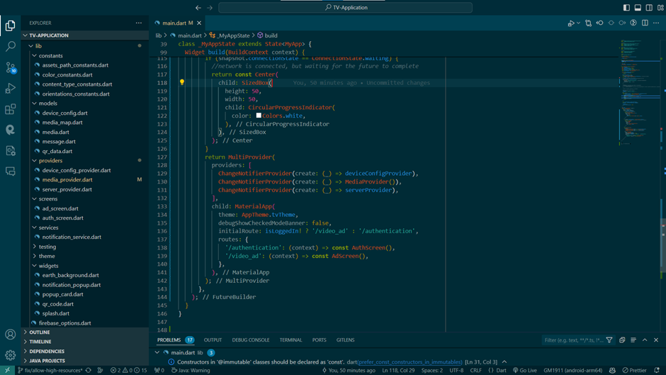

**Figure 4.1: Code and Architecture**

* 1. **User Interface Design**

The user interface (UI) design of the Marwiz TV Application focuses on simplicity, usability, and aesthetics to provide an engaging experience for users. The UI components include:

* Login/Signup Screens: These screens allow users to authenticate and access the application's features.
* Advertisement Display Screen: This screen displays the advertisements in various formats, including images, PDFs, and videos.

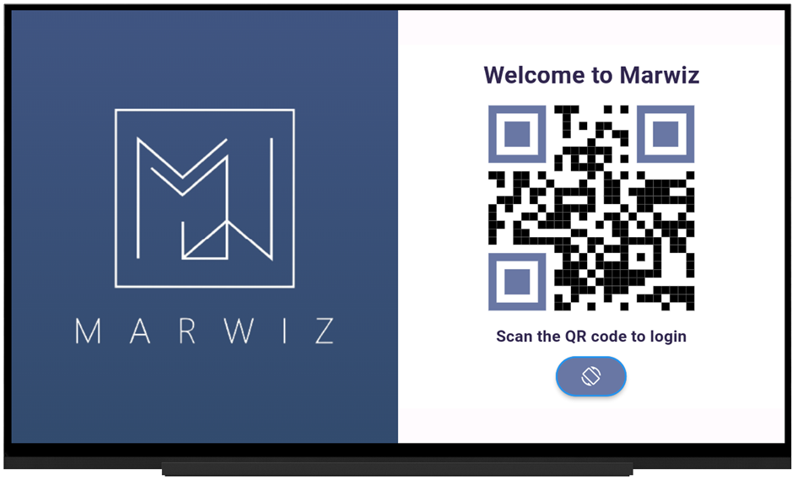

**Figure 4.2: Login/SignUp Screen.**

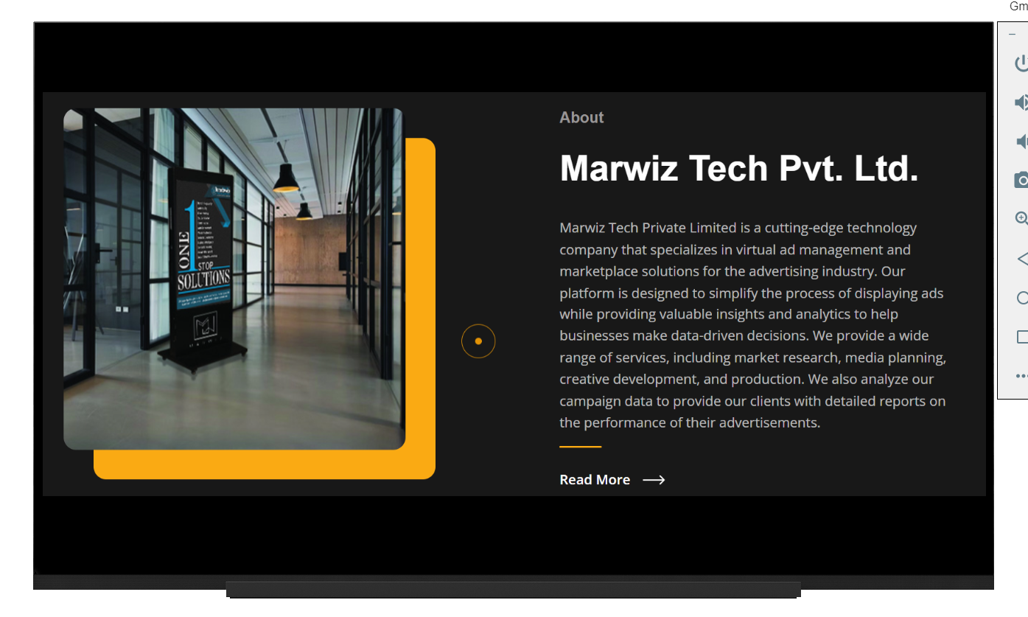

**Figure 4.3: Ad Screen.**

* 1. **Backend System**

The backend system of the Marwiz TV Application is responsible for managing user data, advertisement content, and authentication processes. It comprises the following components:

* User Management Module: This module handles user registration, login authentication, and user profile management functionalities.
* Advertisement Management Module: This module manages the storage, retrieval, and delivery of advertisement content in different formats.
* Database Management: The application utilizes a database system (e.g., Firebase, MongoDB) to store user data, advertisement metadata, and other relevant information.

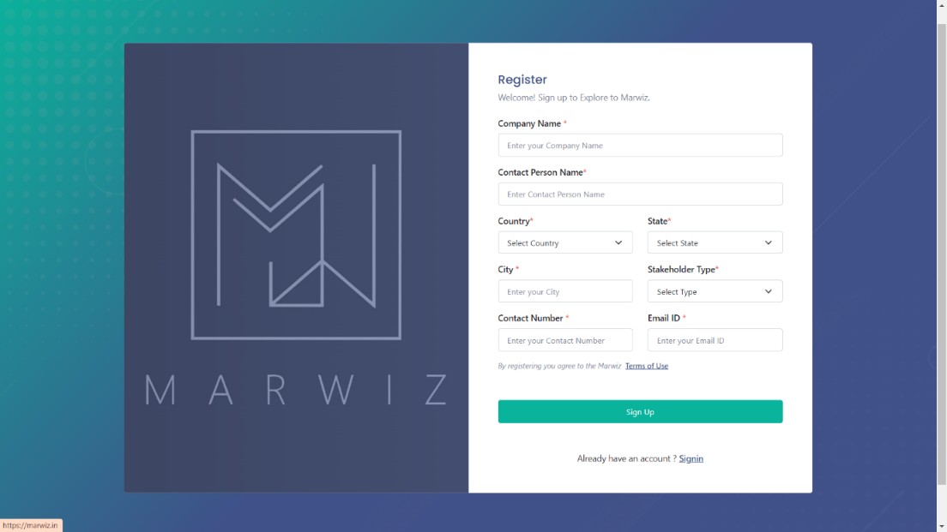

**Figure 4.4: SignUp Screen for Client to manage media.**

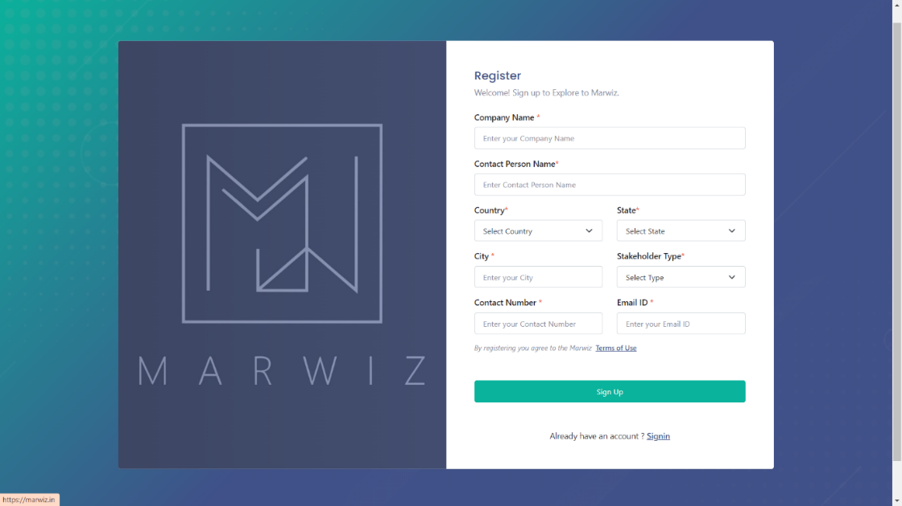

**Figure 4.5: Login Screen for Client to manage media.**

* 1. **Advertisement Delivery Mechanism**

The core functionality of the Marwiz TV Application revolves around delivering targeted advertisements to users after the login/signup process. The advertisement delivery mechanism includes:

* Advertisement Retrieval: Upon successful authentication, the application fetches relevant advertisement content from the backend server based on user preferences and demographics.
* Advertisement Rendering: The retrieved advertisements are rendered on the display screen using appropriate widgets and components in Flutter.
* Advertisement Interaction: Users can interact with the displayed advertisements, such as viewing additional details, downloading attachments (e.g., PDFs), or watching video content.

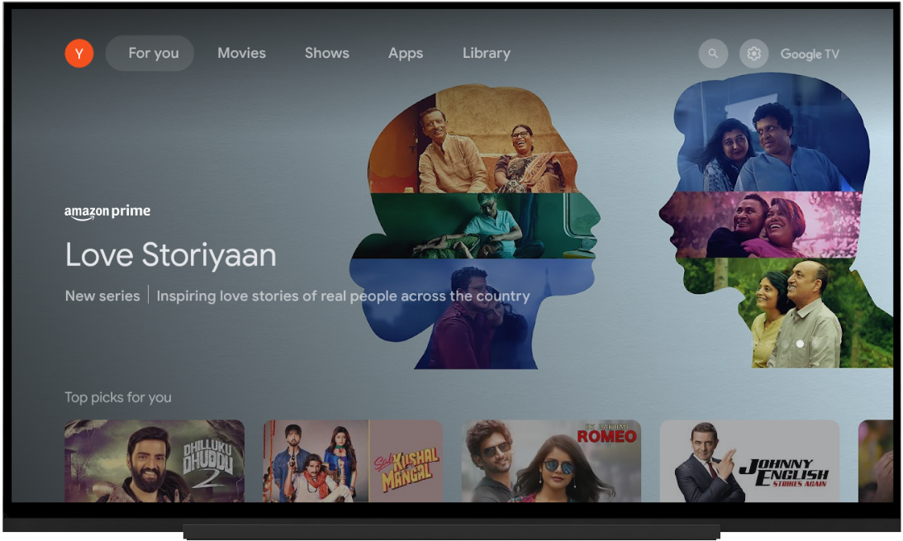

**Figure 4.6: TV Emulator.**

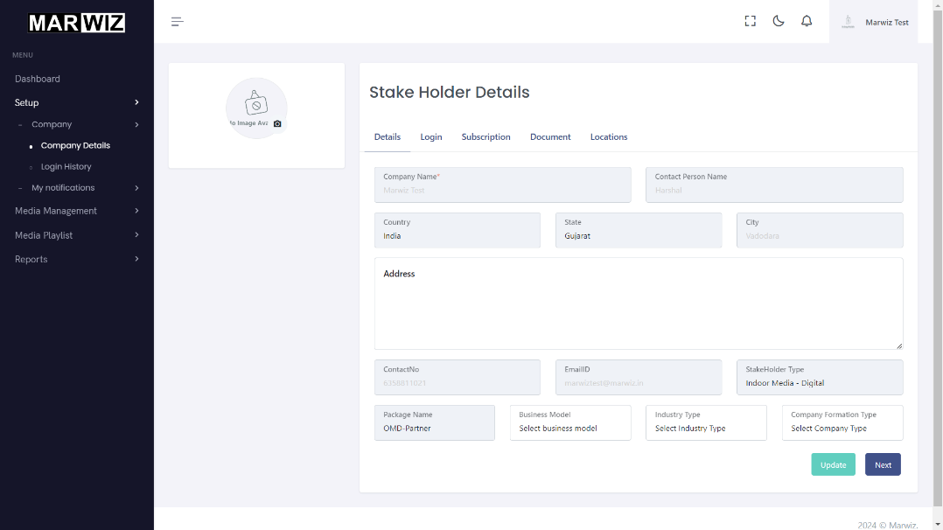

**Figure 4.7: Company Detail.**

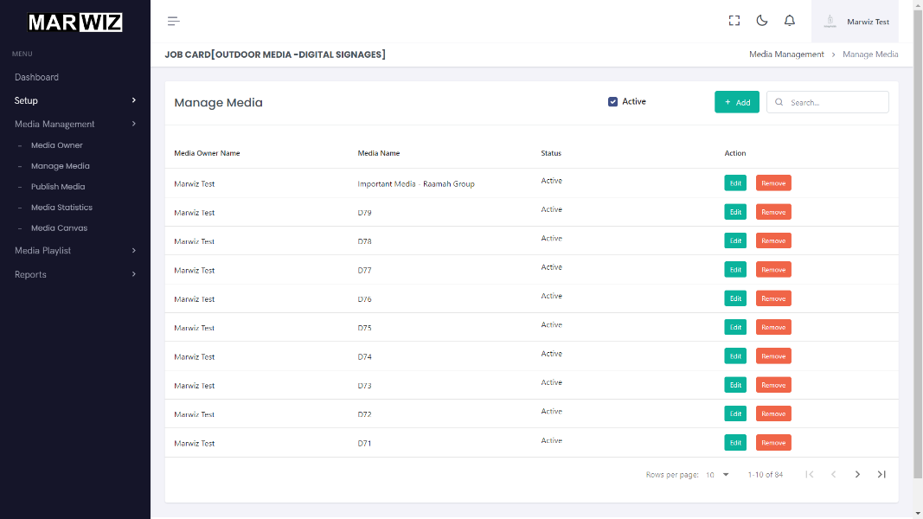

**Figure 4.8: Manage media screen.**

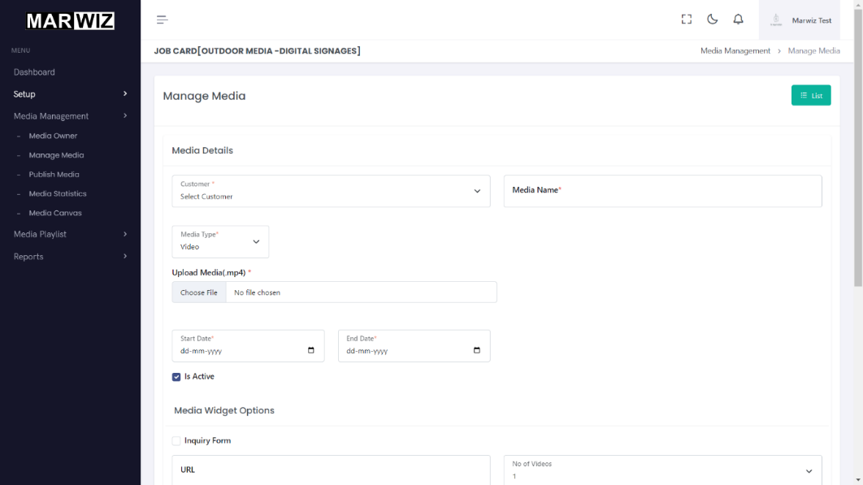

**Figure 4.9: Add media screen.**

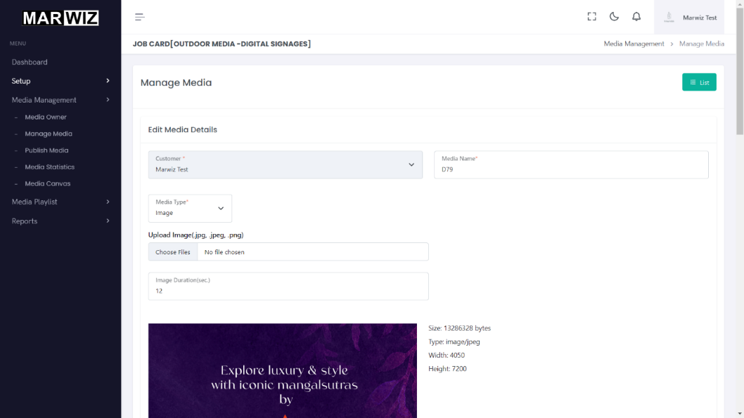

**Figure 4.10: Edit media screen.**

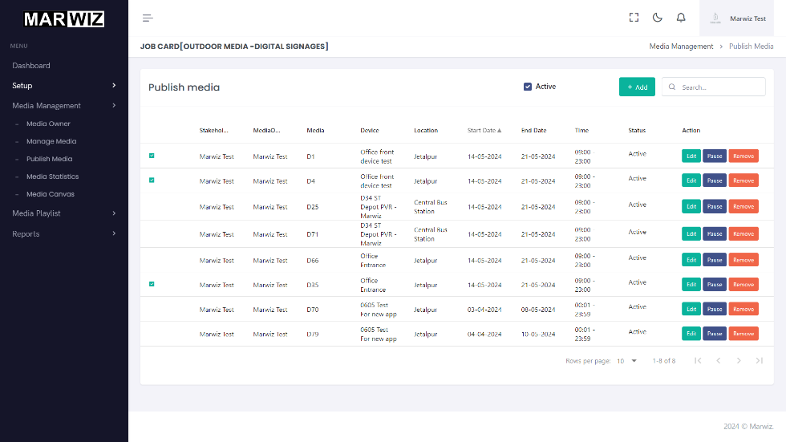

**Figure 4.11: Publish media screen.**

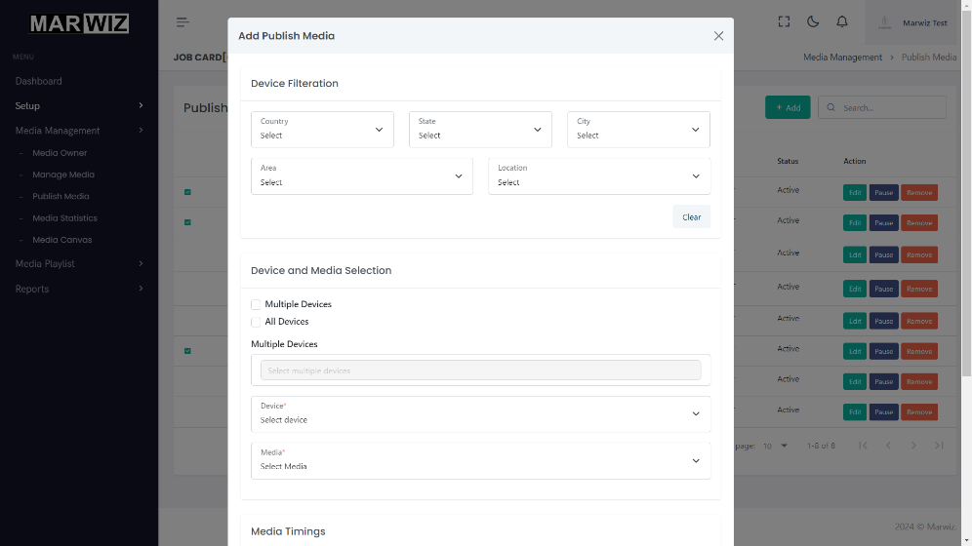

**Figure 4.12: Add publish media screen.**

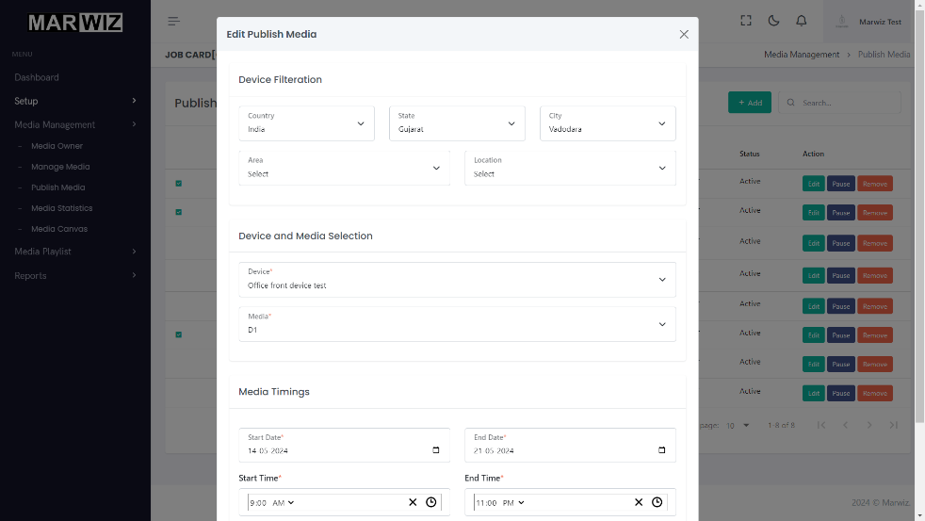

**Figure 4.13: Edit publish media screen.**

* 1. **Performance Optimization**

To ensure optimal performance and responsiveness, the Marwiz TV Application implements various optimization techniques, including:

* Image and Video Caching: Preloading and caching of advertisement media to minimize loading times and bandwidth usage.
* Code Optimization: Writing efficient and optimized Flutter code to minimize resource consumption and enhance application responsiveness.
* Network Optimization: Implementing network optimization strategies (e.g., HTTP caching, data compression) to improve data transfer efficiency.
  1. **Security Considerations**

Security is a paramount concern in the design of the Marwiz TV Application. The following security measures are implemented to safeguard user data and application integrity:

* Secure Authentication: Utilizing secure authentication mechanisms (e.g., OAuth, JWT) to protect user credentials during the login/signup process.
* Data Encryption: Encrypting sensitive user data (e.g., passwords, personal information) stored in the database to prevent unauthorized access.
* Content Security: Ensuring the integrity and authenticity of advertisement content fetched from the backend server to prevent tampering or malicious injection.
  1. **Error Handling and Resilience**

The application incorporates robust error handling and resilience mechanisms to gracefully handle exceptions and unexpected scenarios. This includes:

* Error Logging: Logging error messages and exceptions to facilitate debugging and troubleshooting by developers.
* Graceful Degradation: Implementing fallback mechanisms to handle network failures, server downtimes, or other unforeseen issues without disrupting the user experience.
  1. **Testing and Quality Assurance**

The Marwiz TV Application undergoes rigorous testing and quality assurance procedures to identify and rectify any defects or inconsistencies. This includes:

* Unit Testing: Writing and executing unit tests to validate the functionality of individual components and modules.
* Integration Testing: Conducting integration tests to ensure seamless interaction and compatibility between different application modules.
* User Acceptance Testing (UAT): Soliciting feedback from real users to evaluate the application's usability, performance, and overall satisfaction.
  1. **Future Enhancements**

Lastly, the software design considers potential future enhancements and iterations to further enhance the Marwiz TV Application's functionality and capabilities. This may include:

* Integration with third-party advertisement networks for broader advertisement reach and monetization opportunities.
* Implementation of advanced analytics and reporting features to track advertisement performance and user engagement metrics.
* Incorporation of additional media formats or interactive elements to diversify advertisement content and enhance user interactivity.

**Chapter 5**

**Result and Discussion**

* 1. **Implemented features**

The Marwiz TV Application was successfully developed with the following key features:

* User Authentication Implemented a secure login/signup process for users.
* Advertisement Display: Integrated functionality to display advertisements upon successful login/signup. Advertisements can be in the form of images, PDFs, or videos.
* Platform Compatibility: Ensured compatibility with TV platforms, providing a seamless user experience across various devices.



**Figure 5.1: Advertisement.**

* 1. **Functionality testing**

Comprehensive functionality testing was conducted to validate the performance and reliability of the Marwiz TV Application.

* Unit Testing: Testing individual components and functions to ensure they perform as expected.
* Integration Testing: Verifying the seamless integration of different modules within the application.
* User Acceptance Testing: Engaging real users to assess the application's usability, functionality, and overall satisfaction.
* The testing phase confirmed the robustness and stability of the application, meeting the desired quality standards.
  1. **User feedback**

Feedback from users provided valuable insights into the usability and effectiveness of the Marwiz TV Application. Users appreciated the intuitive user interface, smooth navigation, and the convenience of accessing advertisements on their TV screens. Constructive feedback was also received, focusing on areas for potential improvement such as enhanced customization options and additional features for user engagement

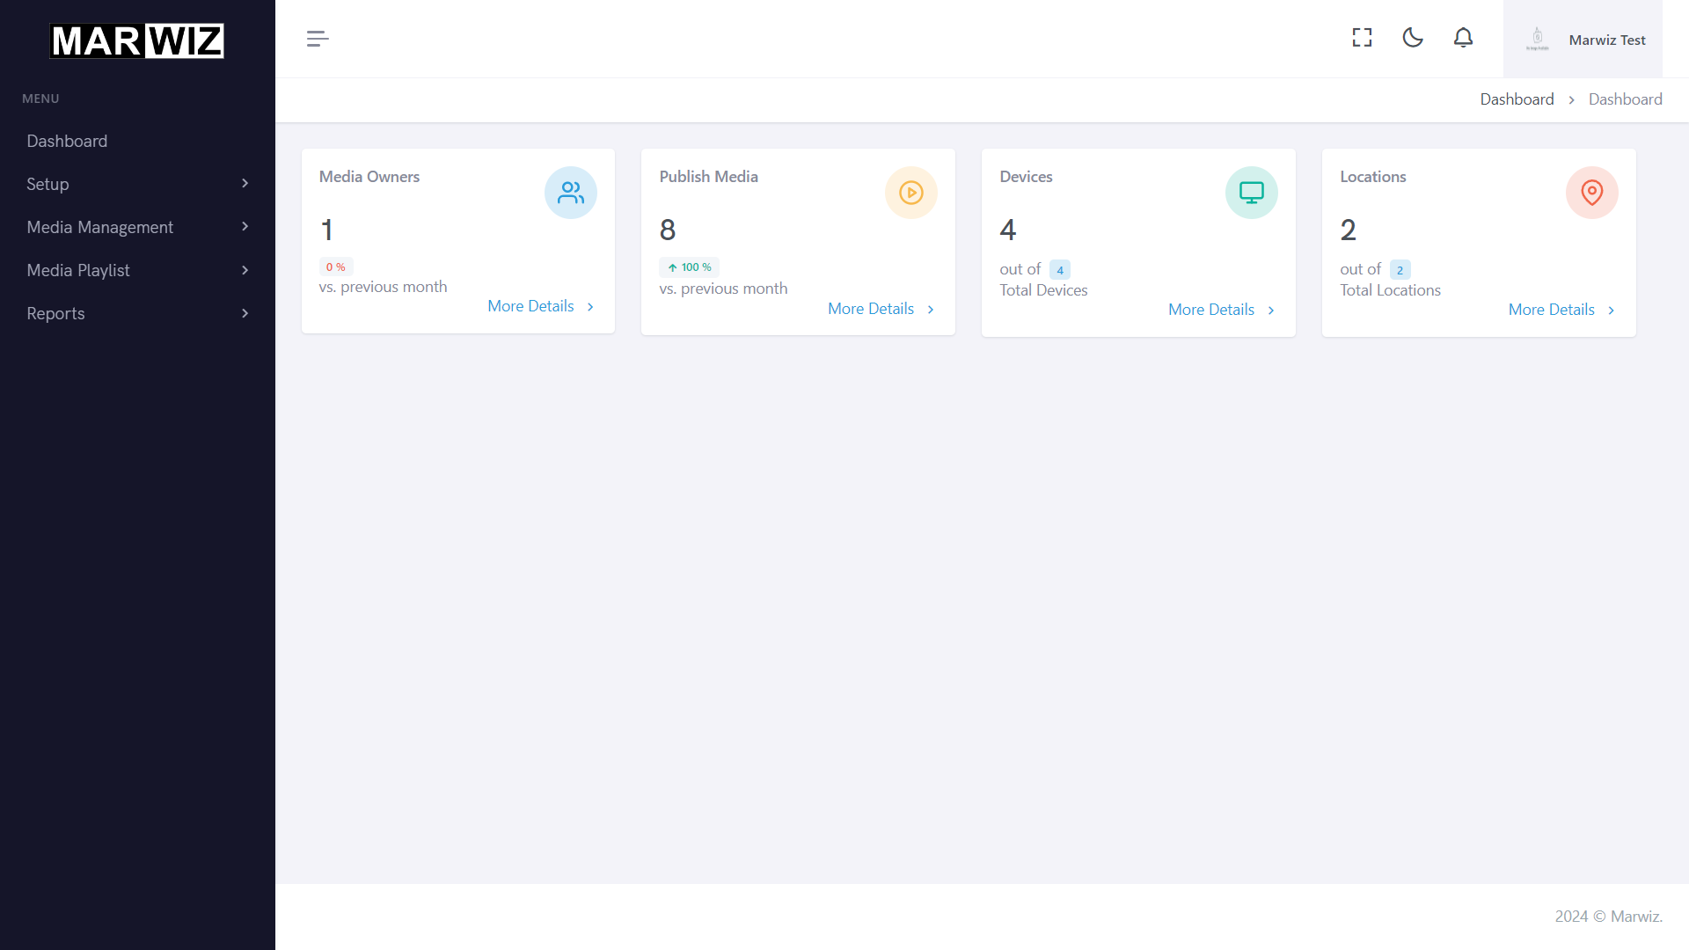

**Figure 5.2: Dashboard.**

* 1. **Performance and Effectiveness Analysis**

The performance and effectiveness of the Marwiz TV Application in delivering targeted advertisements on TV platforms were analyzed based on the following factors:

* Advertisement Reach: Assessing the reach of advertisements to the target audience and the overall exposure achieved through the TV application.
* User Engagement: Analyzing user interaction metrics such as click-through rates, duration of advertisement views, and engagement levels.
* Adaptability: Evaluating the application's adaptability to different TV platforms and its ability to deliver consistent performance across various devices.
* Effectiveness Metrics: Utilizing key performance indicators (KPIs) to measure the success of advertising campaigns, including conversion rates and return on investment (ROI).

The analysis revealed promising results, indicating the Marwiz TV Application's capability to effectively deliver targeted advertisements to users, resulting in increased brand visibility and engagement.

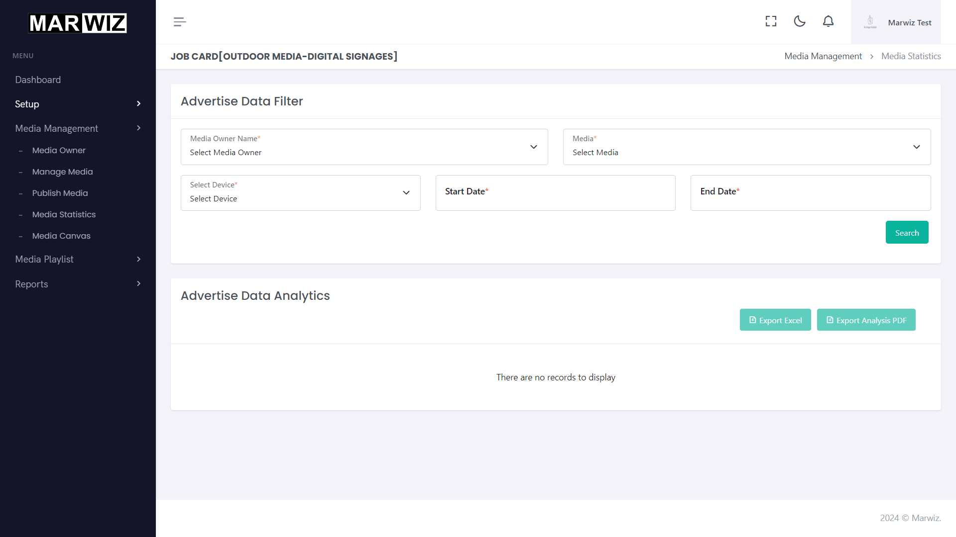

**Figure 5.3: Media Statistics.**

* 1. **Future Directions**

Building upon the findings of this internship project, future directions for enhancing the Marwiz TV Application could include:

* Enhanced Personalization: Implementing advanced algorithms for personalized advertisement recommendations based on user preferences and viewing history
* Integration with Analytics Tools: Incorporating analytics tools to gather in-depth insights into user behavior and advertisement performance.
* Expansion to Additional Platforms: Expanding the application's compatibility to support additional TV platforms and devices, further extending its reach and accessibility.

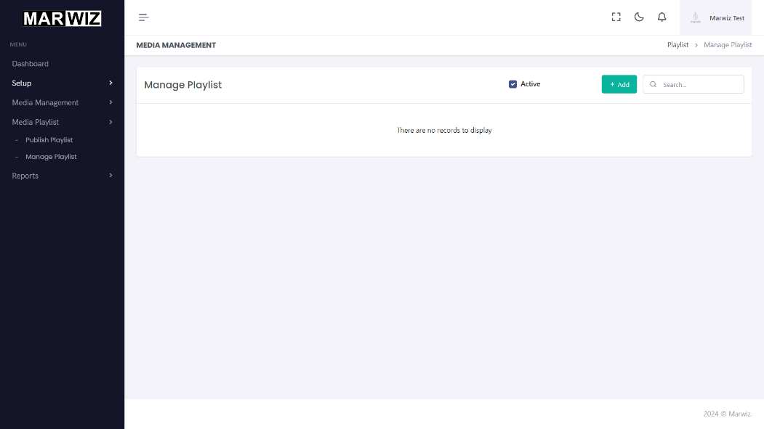

**Figure 5.4: Media Playlist.**

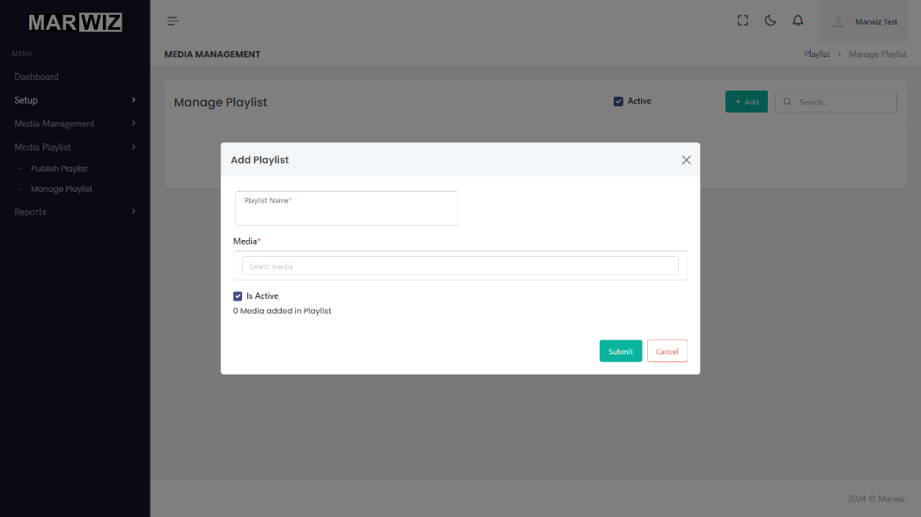

**Figure 5.5: Add Media Playlist.**

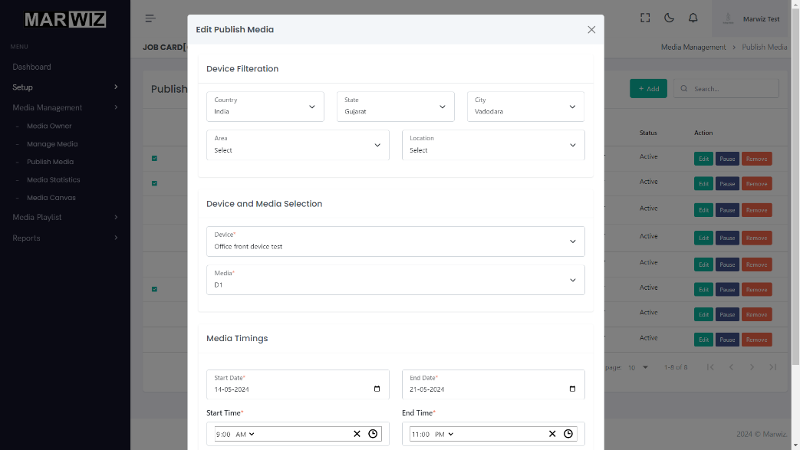

**Figure 5.6: Edit Media Playlist.**

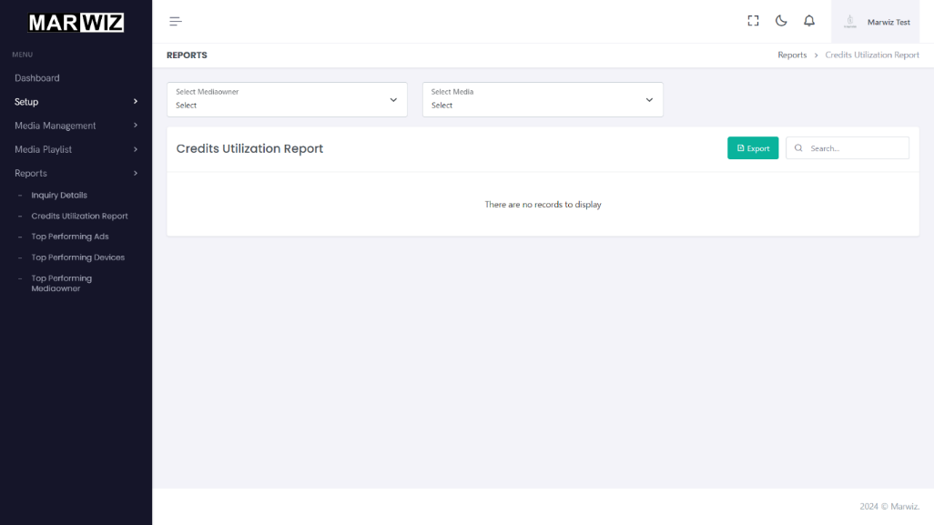

**Figure 5.7: Credit Utilisation.**

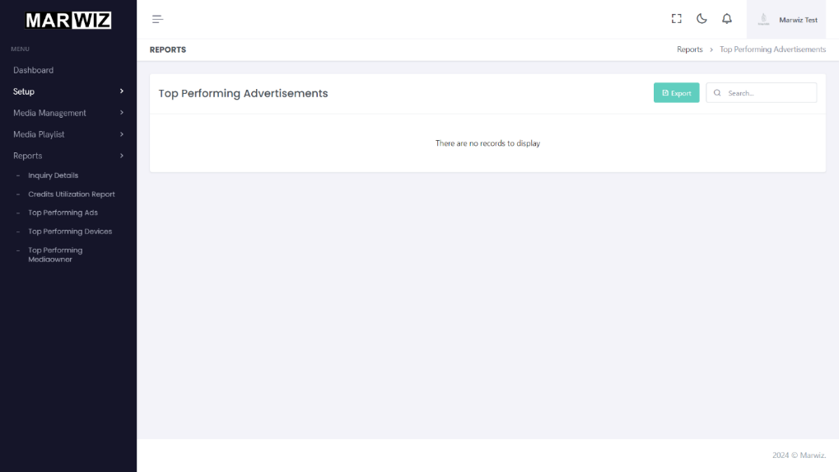

**Figure 5.8: Top performing Ads.**

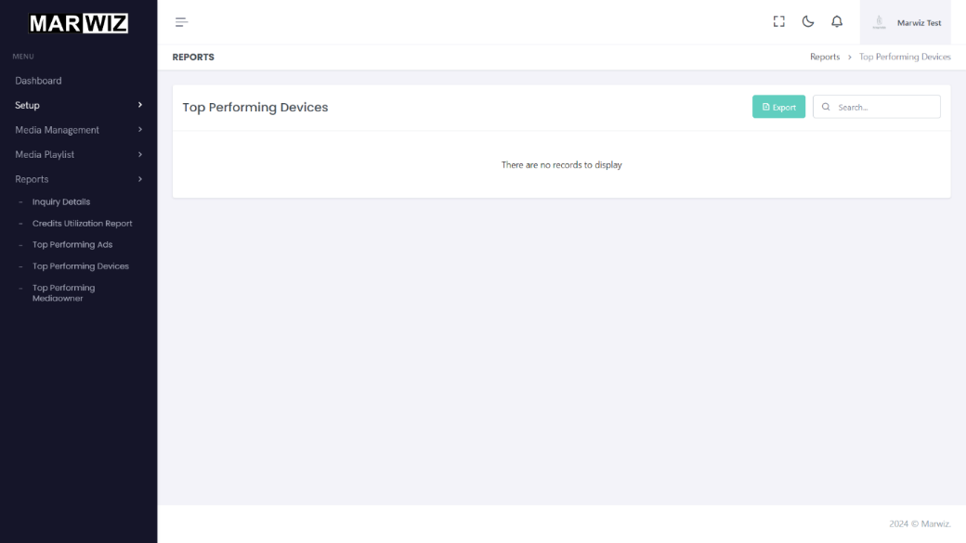

**Figure 5.9: Top performing devices.**

**Chapter 6**

**Conclusion and Future Scope**

* 1. **Conclusions**

The Marwiz TV Application project has been successfully implemented, achieving its primary goal of displaying targeted advertisements following a seamless login/signup process. Leveraging Flutter and Dart for cross-platform development proved to be highly effective, enabling us to create a robust and visually appealing application. The project demonstrated the importance of targeted advertising in catering to modern media consumption habits, thus underscoring the relevance of Marwiz in the digital advertising landscape. Overall, we have met our project objectives and fulfilled the goals set forth for the internship.

* 1. **Lessons Learned**

Throughout the development process, we encountered various challenges, but we successfully overcame them by implementing effective solutions and adhering to best practices. Effective project management, collaboration, and communication were crucial in achieving project milestones and delivering quality results. We have learned the importance of adaptability and flexibility in responding to changing project requirements. Moving forward, we aim to apply these lessons to future projects, ensuring smoother development processes and superior outcomes.

* 1. **Contributions to the Field**

The Marwiz TV Application project makes significant contributions to the field of TV advertising platforms and Flutter app development. Its innovative features, such as targeted advertisement delivery and seamless user experience, have the potential to revolutionize digital advertising strategies. Marwiz serves as a valuable example of the capabilities of cross-platform development frameworks like Flutter and highlights the opportunities for innovation in the digital media and advertising technology sectors.

**6.4 Future Scope**

Looking ahead, there are several avenues for further research, development, and enhancement of the Marwiz TV Application. We envision integrating additional features to enhance user engagement and interactivity, such as personalized advertisement targeting based on user preferences and behavior analysis. Expanding the reach of Marwiz to other platforms, such as smart TVs and mobile apps, could broaden its user base and increase its impact. Moreover, the integration of advanced technologies like machine learning algorithms and augmented reality holds promise for enriching the advertisement viewing experience and improving campaign effectiveness. Ensuring the scalability of the platform and staying abreast of industry trends through continuous updates and maintenance will be critical to Marwiz's long-term success.

**6.5 Final Remarks**

In conclusion, the Marwiz TV Application project has been a fulfilling and enlightening experience, contributing to our professional development journey. We are grateful for the support and guidance of our mentors, colleagues, and stakeholders throughout the project. As we move forward, we are excited to continue exploring new opportunities and pushing the boundaries of digital media and advertising technology. Marwiz represents just the beginning of our journey toward innovation and excellence in the field, and we look forward to what the future holds.

**References:**

Documentations:

1. <https://flutter.dev/>
2. <https://dart.dev/>
3. <https://pub.dev/>
4. <https://firebase.google.com/>
5. <https://www.mongodb.com/>
6. <https://nodejs.org/en>

Articles:

1. <https://javiercbk.github.io/json_to_dart/>
2. <https://blog.codemagic.io/rest-api-in-flutter/>
3. <https://medium.com/@raphaelrat_62823/consuming-rest-api-in-flutter-a-guide-for-developers-2460d90320aa>

Course:

1. <https://www.udemy.com/course/learn-flutter-dart-to-build-ios-android-apps>
2. <https://www.udemy.com/course/flutter-bootcamp-with-dart>

Tutorial:

1. <https://www.youtube.com/playlist?list=PLjVLYmrlmjGfGLShoW0vVX_tcyT8u1Y3E>
2. <https://www.youtube.com/playlist?list=PLFyjjoCMAPtzgITDreXNNkSWLKbd1wf51>